Ex.no:7b | DATA VISUALIZATION USING TABLEAU-  FOOD WASTE PREDICTION DATASET
AIM
To connect, analyze, visualize, and create an interactive dashboard using Tableau with the Google Play Store Dataset to analyze application ratings, category-wise applications, reviews, installations, application types, content ratings, and rating trends.
SOFTWARE REQUIREMENTS
• Tableau Desktop / Tableau Public
• Microsoft Excel
• CSV Dataset
• Windows Operating System
THEORY
Tableau is a powerful Business Intelligence (BI) and Data Visualization tool used to create interactive dashboards and reports.
The Google Play Store Dataset contains information about applications available on the Google Play Store, including their ratings, reviews, installations, categories, types, prices, content ratings, and update information.
The dataset includes:
• App
• Category
• Rating
• Reviews
• Installs
• Type
• Price
• Content Rating
• Last Updated
• Current Version
• Android Version
Tableau allows users to analyze this data and identify highly rated applications, popular categories, applications with high reviews and installations, Free and Paid application distribution, and rating trends.
TABLEAU ARCHITECTURE
Google Play Store Dataset
↓
Data Connection
↓
Worksheets
↓
Visualizations
↓
Dashboard
↓
Story
LEARNING OUTCOMES
After completing this experiment, students will be able to:
- Connect the Google Play Store Dataset to Tableau
- Create worksheets using dimensions and measures
- Generate different charts and visualizations
- Analyze application rating trends
- Compare applications across different categories
- Analyze review and installation patterns
- Analyze Free and Paid application distribution
- Apply filters and parameters
- Create calculated fields
- Build interactive dashboards
- Create stories for Google Play Store analysis
ALGORITHM 1 – CONNECTING DATA SOURCE
Step 1
Open Tableau Desktop.
Step 2
Select Connect.
Step 3
Choose Microsoft Excel or Text File depending on the dataset format.
Step 4
Browse and select the Google Play Store Dataset.
Step 5
Open the dataset.
Step 6
Verify the imported fields such as:
- App
- Category
- Rating
- Reviews
- Installs
- Type
- Price
- Content Rating
- Last Updated
- Current Version
- Android Version
OUTPUT
Google Play Store Dataset loaded into Tableau successfully.
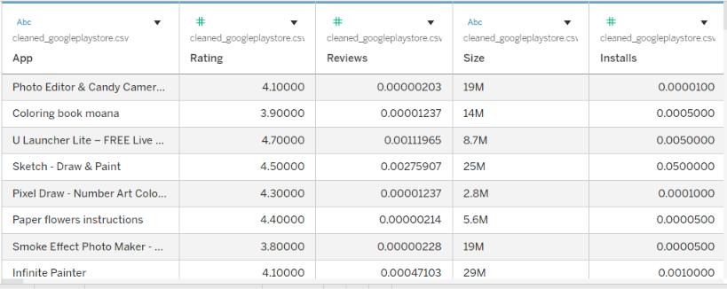
ALGORITHM 2 – CREATING WORKSHEET
Objective
To compare the average application rating across different categories.
Step 1
Open Sheet 1.
Step 2
Drag Category to Rows.
Step 3
Drag Rating to Columns.
Step 4
Select Bar Chart from the visualization options.
Step 5
Change the aggregation of Rating to Average.
Step 6
Enable Show Mark Labels to display the average rating.
Step 7
Sort the categories based on average rating.
Step 8
Add the title Average Rating by Category.
OUTPUT
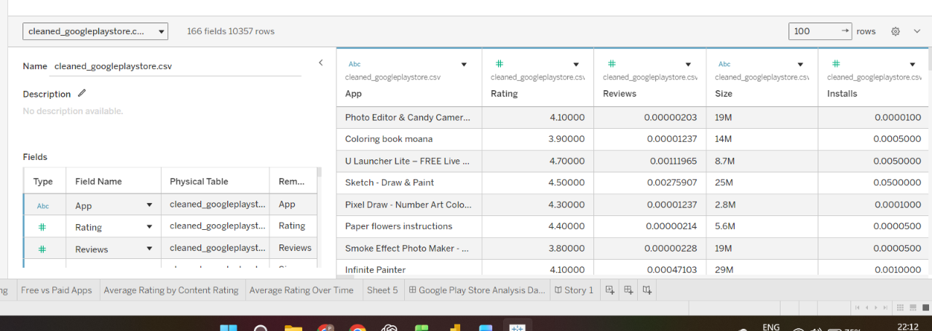
Worksheet created successfully.
INTERPRETATION
The bar chart displays the average rating of applications in different categories. It helps compare the rating performance of various application categories.
ALGORITHM 3 – BAR CHART CREATION
Objective
To compare the popularity of applications based on the number of reviews.
Step 1
Drag App to Rows.
Step 2
Drag Reviews to Columns.
Step 3
Select Bar Chart from Show Me.
Step 4
Sort the applications in descending order based on Reviews.
Step 5
Select the top applications using a suitable filter.
Step 6
Enable Show Mark Labels.
Step 7
Add the title Top Applications by Reviews.
OUTPUT
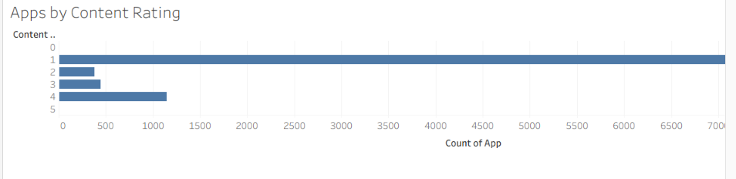
Bar chart created successfully.
INTERPRETATION
The bar chart helps identify applications having a higher number of reviews and provides an indication of application popularity.
ALGORITHM 4 – PIE CHART CREATION
Objective
To analyze the distribution of Free and Paid applications.
Step 1
Drag Type to the view.
Step 2
Select Pie Chart from Show Me.
Step 3
Drag App to Angle.
Step 4
Drag Type to Color.
Step 5
Enable Show Labels.
Step 6
Display the percentage of Free and Paid applications.
Step 7
Add the title Free and Paid Application Distribution.
OUTPUT
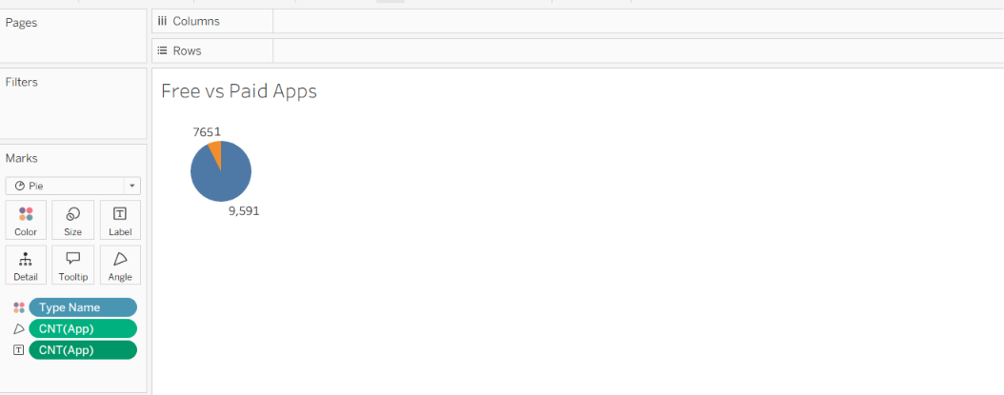
Free and Paid Application Pie Chart created successfully.
INTERPRETATION
The pie chart shows the proportion of Free and Paid applications available in the Google Play Store dataset.
ALGORITHM 5 – LINE CHART CREATION
Objective
To analyze the trend of application ratings over time.
Step 1
Drag Last Updated to Columns.
Step 2
Drag Rating to Rows.
Step 3
Change the aggregation of Rating to Average.
Step 4
Select Line Chart from Show Me.
Step 5
Arrange the date field in a suitable time format.
Step 6
Enable data labels if required.
Step 7
Analyze the average rating trend over different time periods.
Step 8
Add the title Averag
e Rating Over Time.
OUTPUT
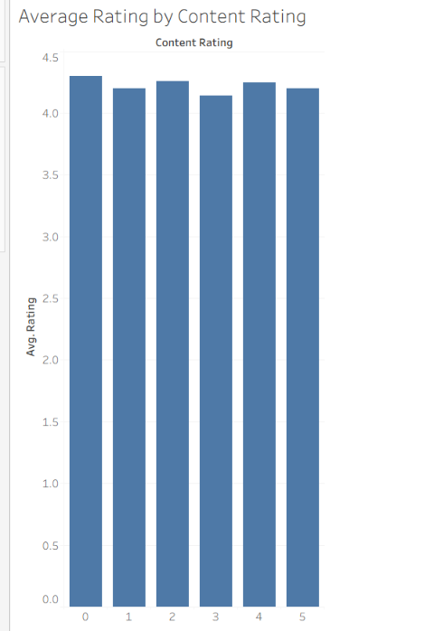
Average Rating Over Time Line Chart created successfully.
INTERPRETATION
The line chart shows how the average application rating changes over time and helps identify changes in application rating patterns.
ALGORITHM 6 – CREATING CALCULATED FIELD
Objective
To calculate the average number of reviews received per installation.
Step 1
Select:
Analysis → Create Calculated Field
Step 2
Enter the field name:
Review Percentage
Step 3
Enter the formula:
([Reviews] / [Installs]) * 100
Step 4
Click OK.
Step 5
Use the calculated field in the worksheet for further analysis.
OUTPUT
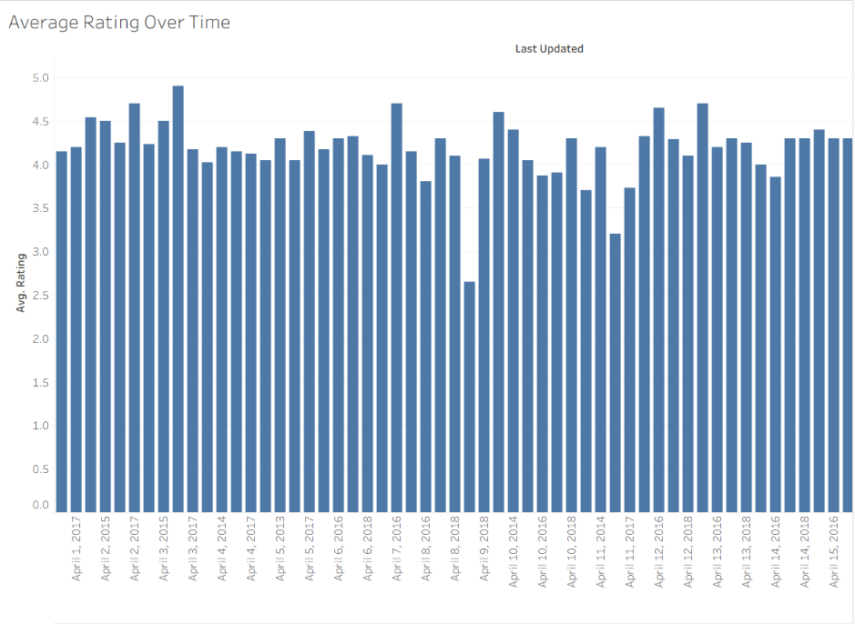
Calculated field created successfully.
INTERPRETATION
The calculated field helps compare the number of reviews with installations and provides an indication of user engagement with applications.
ALGORITHM 7 – APPLYING FILTERS
Objective
To analyze applications based on a selected category.
Step 1
Drag Category to the Filters shelf.
Step 2
Select the required category.
Step 3
Click Show Filter.
Step 4
Select a category such as GAME or EDUCATION.
Step 5
Observe the updated charts.
OUTPUT
The visualizations display only applications belonging to the selected category.
INTERPRETATION
The Category filter allows users to focus on a particular application category and perform detailed analysis.
ALGORITHM 8 – CREATING PARAMETER
Objective
To dynamically display applications based on a user-defined minimum rating.
Step 1
Select:
Create Parameter
Step 2
Specify the parameter name:
Minimum Rating
Step 3
Set the data type as:
Float
Step 4
Set the required minimum rating value.
Step 5
Create a calculated field using the parameter.
Formula
[Rating] >= [Minimum Rating]
Step 6
Apply the calculated field to the required visualization.
Example
Minimum Rating = 4.5
OUTPUT
The visualization displays applications having a rating of 4.5 or above.
INTERPRETATION
The parameter allows users to dynamically identify highly rated applications based on a selected rating threshold.
ALGORITHM 9 – DASHBOARD CREATION
Objective
To create an interactive Google Play Store Analysis Dashboard.
Step 1
Create multiple worksheets.
Step 2
Select Dashboard → New Dashboard.
Step 3
Drag the required worksheets into the dashboard.
Step 4
Arrange the charts clearly.
Step 5
Add filters for:
- Category
- Type
- Content Rating
- Rating
- Last Updated
Step 6
Add the Minimum Rating parameter.
Step 7
Add appropriate titles and labels.
Step 8
Add KPI cards for:
- Total Applications
- Average Rating
- Total Reviews
- Total Installs
OUTPUT
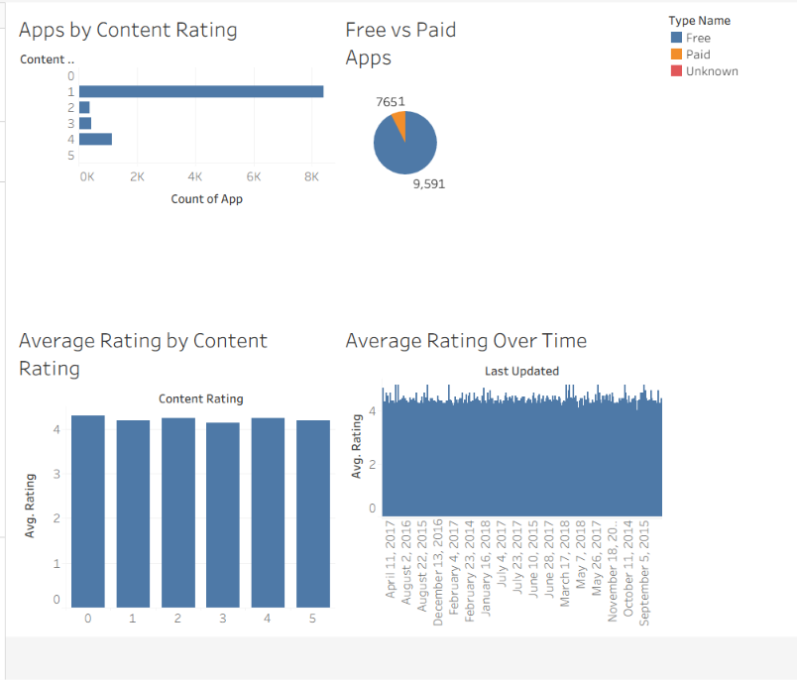
Interactive Google Play Store Analysis Dashboard created successfully.
INTERPRETATION
The dashboard provides a consolidated view of application ratings, categories, reviews, installations, and application types. Users can interact with the dashboard using filters and parameters.
ALGORITHM 10 – STORY CREATION
Objective
To present the Google Play Store analysis through a sequence of visual insights.
Step 1
Create the required worksheets.
Step 2
Create the Google Play Store Analysis Dashboard.
Step 3
Select Story → New Story.
Step 4
Add the dashboard and required worksheets as story points.
Step 5
Arrange the story points in a logical sequence.
Step 6
Present the findings.
Example Story
Story Point 1 – Overall Application Analysis
Displays total applications, average rating, total reviews, and total installations.
Story Point 2 – Rating Trend Analysis
Shows how application ratings vary over time.
Story Point 3 – Category-wise Analysis
Compares average ratings and application popularity across different categories.
Story Point 4 – Application Type Analysis
Shows the distribution of Free and Paid applications.
Story Point 5 – Review and Installation Analysis
Compares applications based on reviews and installations.
Story Point 6 – Final Google Play Store Analysis
Summarizes the major patterns and observations obtained from the dataset.
APPLICATIONS
Application Performance Analysis
Analysis of application ratings, reviews, installations, and popularity.
Category Analysis
Identification of highly rated and popular application categories.
User Engagement Analysis
Comparison of reviews and installations to understand application engagement.
Business Intelligence
Interactive visualization and dashboard-based Google Play Store analysis.
Decision Making
Identification of popular, highly rated, and highly reviewed applications for better decision-making.
App Market Analysis
Analysis of Free and Paid applications, content ratings, categories, and application trends.

RESULT:

